**Full Project Documentation for Online Shopping Site**

**(UI and Backend)**

|  |
| --- |
| **Product Table** |
| Product Id |
| ProductName |
| Price |
| Stock Quantity |
| Category Id |

|  |
| --- |
| **Order** |
| Order Id |
| Order Date |
| Total Amount |

**Database Schema (Tables): -**

|  |
| --- |
| **Order Item** |
| Order Item Id |
| Order Id |
| Product Id |
| Quantity |
| Unit Price |

|  |
| --- |
| **Cart** |
| Cart Id |
| Product Id |
| Quantity |

|  |
| --- |
| **Category** |
| Category Id |
| Category Name |

**Table Relations: -**

|  |  |
| --- | --- |
| Product to Category | Many to One |
| Order to Order Item | One to Many |
| Product to Order Item | One to Many |
| Product to Cart | One to Many |

**Objectives: -**

* Implementing GET, POST, PUT and DELET for the all entities.
* Creating Error Free Restful API for better Data Processing.
* Accept and Return data in the standard Format.
* Better Relationship between entities for better data retrieval.

**Users: -**

* **Customer**

Customers are responsible for purchasing.

**Events: -**

* **Product: -** Product will updated, created and deleted.
* **Category: -** Category will updated, created and deleted.
* **Orders:** - Orders will updated, created and deleted.
* **Cart: -**Cartwill updated, created and deleted.

**List of Forms: -**

* **Product: -**
  + Product List
  + Product Add
  + Product Update
* **Category: -**
  + Category List
  + Category Add
* **Order: -**
  + Order List
* **Cart: -**
  + Product List
  + Product Add
  + Product Update

**Expected Deliverables: -**

* Create an API that will take Product Name as an input and return All the details with Category (case insensitive search)
* Create an API that will retrieving Product by Order Id.
* Create an API that Will take Cart Id and Return that Category Name.
* When Product Added by Product page it Will Transferred to the Cart Page.

**Layout of Forms**: -

1)Home Page

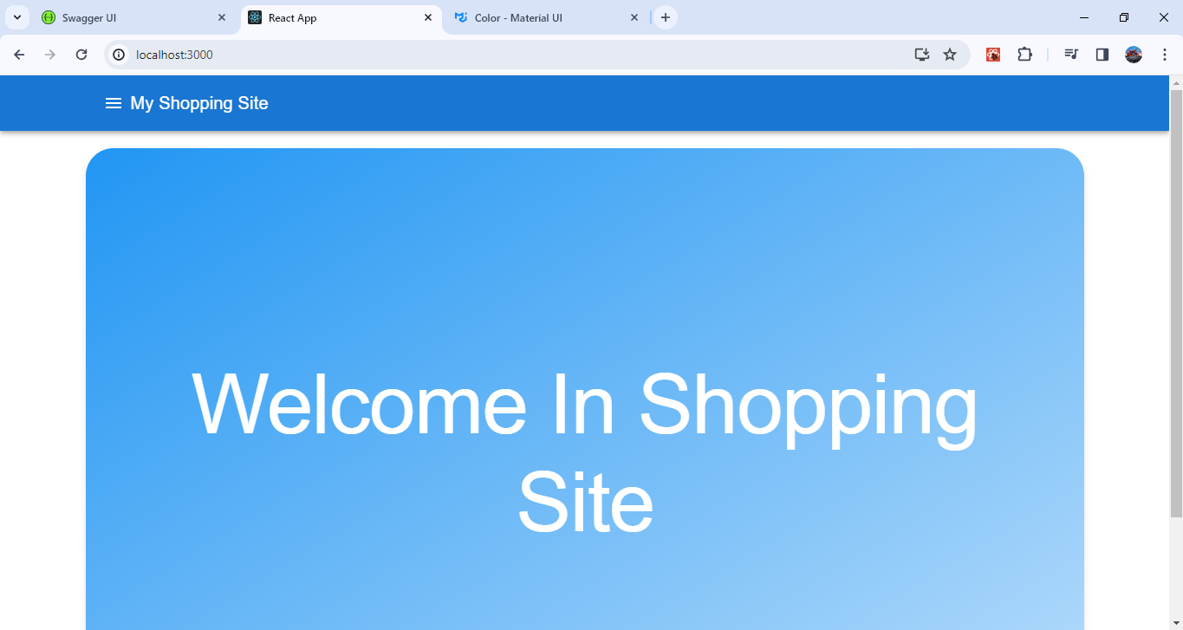

2)Product Page

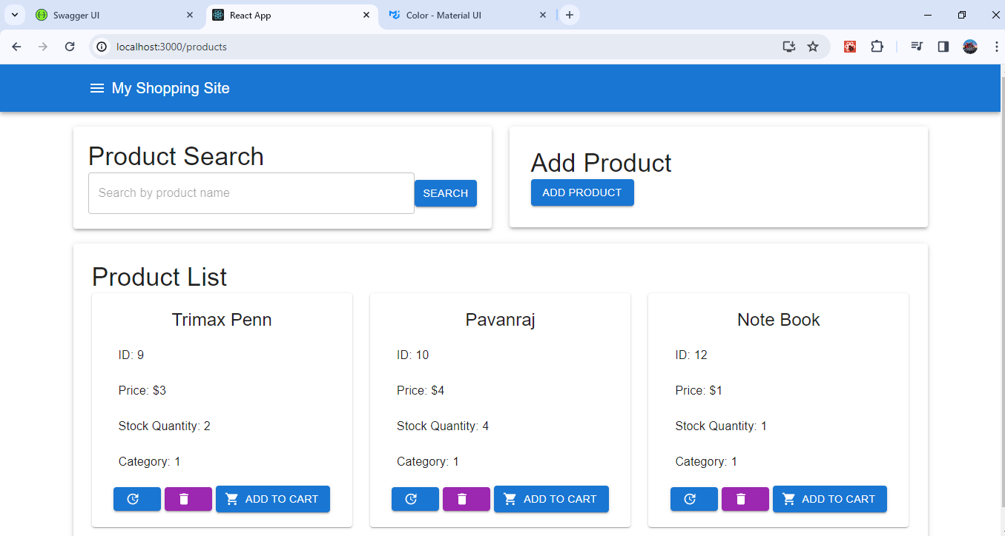

3)Order Item List

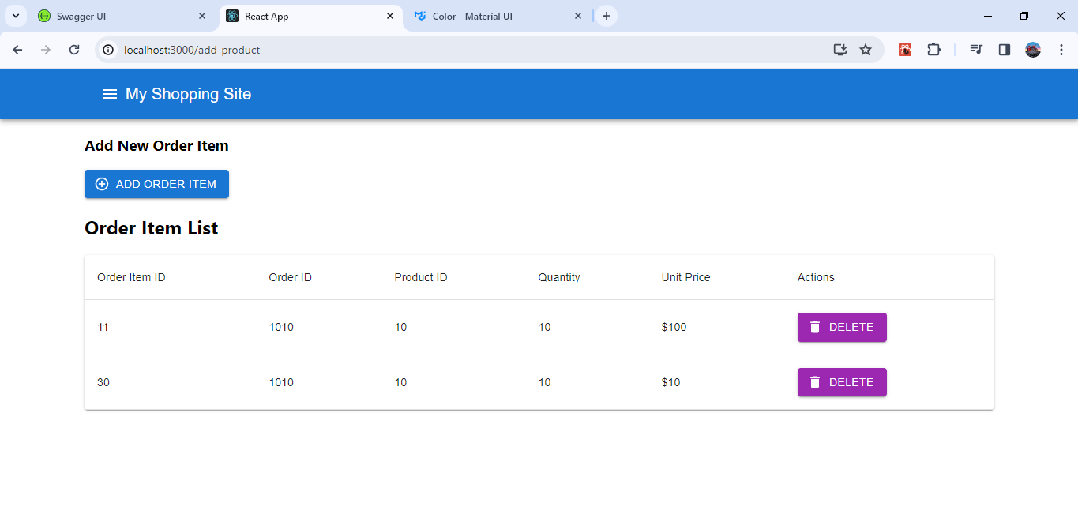

4)Orders

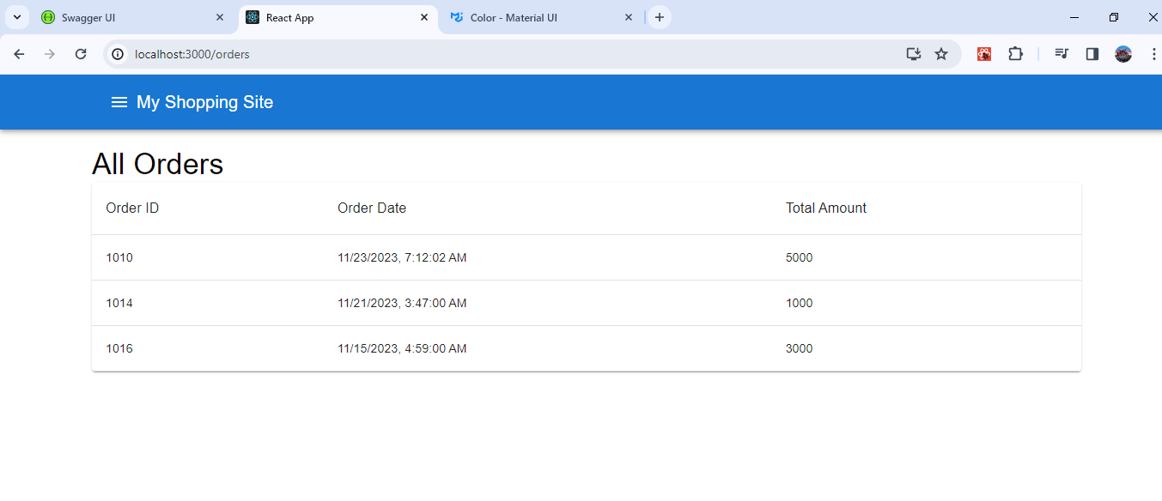

5)My Category

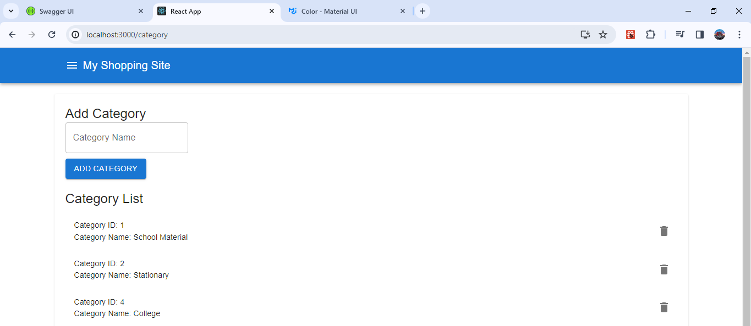

6)My Cart

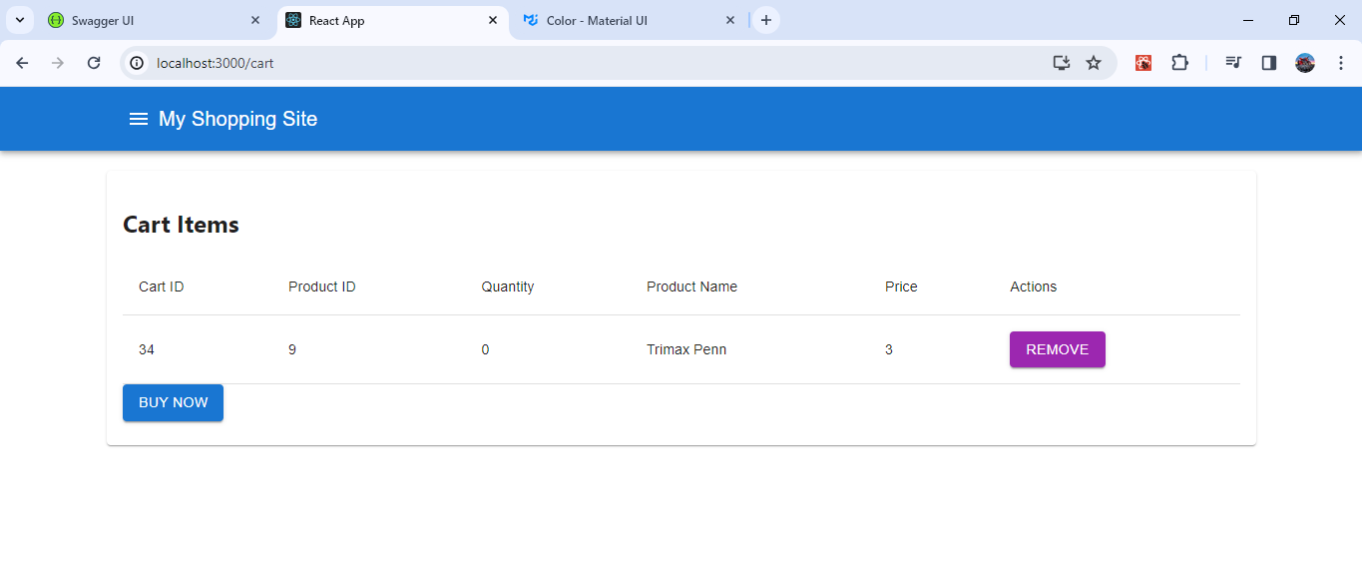

7)Order ID Search

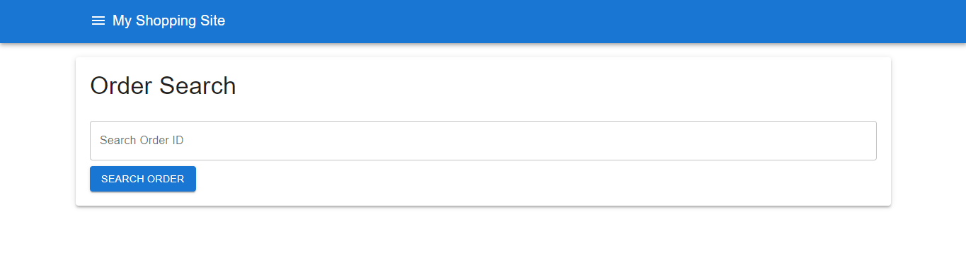

8)Cart ID Search

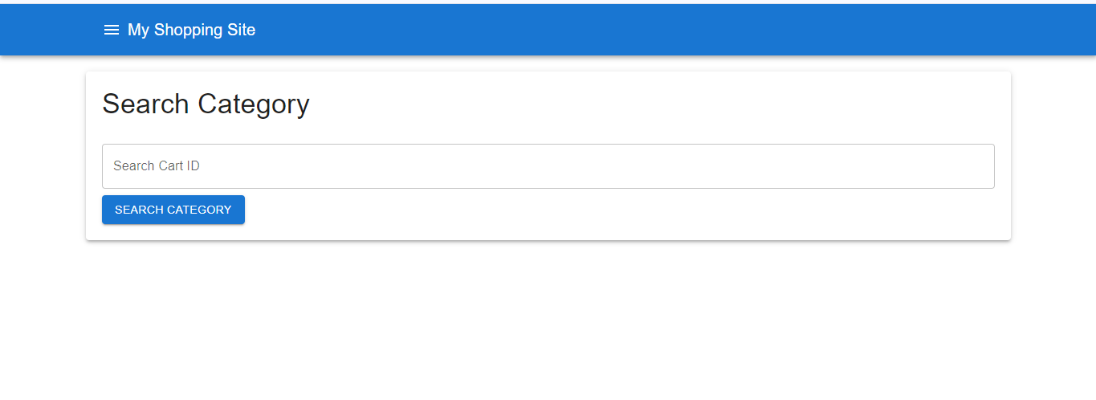

**Result: -**

* **Successfully Implemented All the Deliverables as Per the Expectations and also added Extra Functionality.**
* **All Things are Working Properly.**

**\*\*\***